PROJECT

Arduino Door Lock Using 4x4 Keypad and Servo Motor

In this project i have tried to explain how to built a Door Lock Security System with an Arduino and Keypad.

I have used 4x4 Keypad for this project but you can use different models but do not forget to change some parts in the code.

Actually it is very easy to use this component with an Arduino , however only thing that you may not like is 4x4 keypad need 8 PIN to work properly.

Circuit and Working

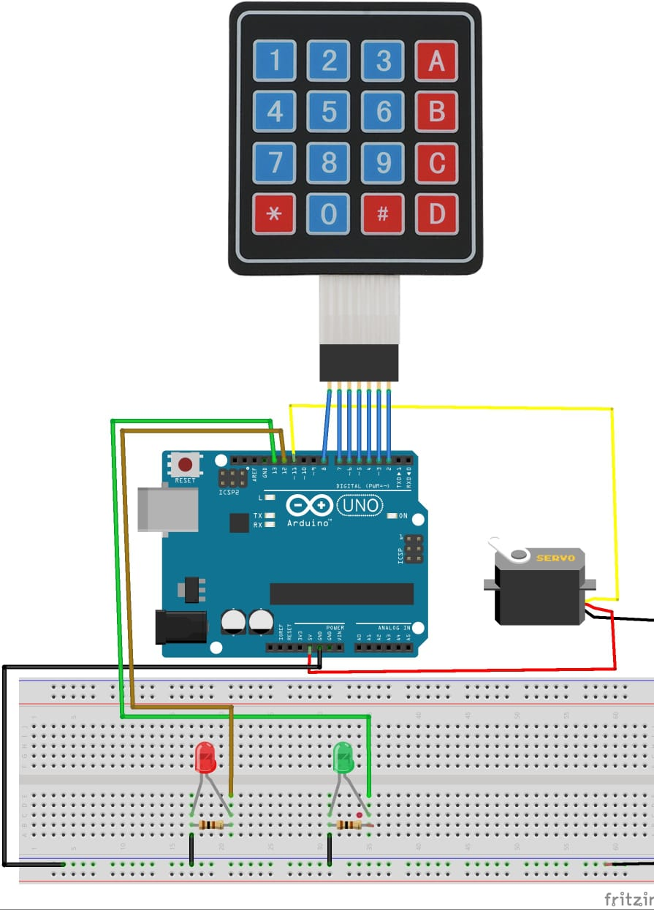

PIN CONNECTIONS

row Pins is connected to { 8, 7, 6, 9 };

col Pins to { 5, 4, 3, 2 };

red led Pin to 12;

green led Pin to 13;

WORKING

As theft is increasing day by day, security is becoming a major concern. In this project, we will make a digital door lock system with keypad using an Arduino Uno. It will open your door only when the right password (**\*#C9**) is entered and it will start beeping for a wrong password.

CODE

#include <Keypad.h>

#include <Servo.h>

Servo servo_Motor;

char* password = "123";

int position = 0;

const byte ROWS = 4;

const byte COLS = 4;

char keys[ROWS][COLS] = {

{'1','2','3','A'},

{'4','5','6','B'},

{'7','8','9','C'},

{'*','0','#','D'}

};

byte rowPins[ROWS] = { 8, 7, 6, 9 };

byte colPins[COLS] = { 5, 4, 3, 2 };

Keypad keypad = Keypad( makeKeymap(keys), rowPins, colPins, ROWS, COLS );

int redPin = 12;

int greenPin = 13;

void setup()

{

pinMode(redPin, OUTPUT);

pinMode(greenPin, OUTPUT);

servo_Motor.attach(11);

setLocked(true);

}

void loop()

{

char key = keypad.getKey();

if (key == '*' || key == '#')

{

position = 0;

setLocked(true);

}

if (key == password[position])

{

position ++;

}

if (position == 3)

{

setLocked(false);

}

delay(100);

}

void setLocked(int locked)

{

if (locked)

{

digitalWrite(redPin, HIGH);

digitalWrite(greenPin, LOW);

servo_Motor.write(11);

}

else

{

digitalWrite(redPin, LOW);

digitalWrite(greenPin, HIGH);

servo_Motor.write(90);

}

}

